**Task 1: Web Project Topic Selection:**

1) The purpose of my Website is to display my favorite hobby; Collecting, specifically collecting coins and bills. Here are some reasons why I want to create the website:

- Collecting is fun/enjoyable and I want everyone to know that on my website.

- I would like others to see what I have to display in my collection.

- Maybe if other users are into collecting also they would like to see certain items I have in my collection and possibly trade with me.

- My collection is maybe a learning experience for users who are interested

- The website may grow in popularity, which as a result it may gain more attraction.

2) What I want my website to accomplish is to look visually neat and create a different experience for users who are on it. In order for my website to be considered a success, my website might have items displayed in my collection which are rare/unique so that other users may be interested in that. Here is some goal to achieve that:

- Display only certain items in my collection.

- Have a short description to catch the user’s attention.

- Have an image to go along with the description of my items on display.

3) My targeted audience is mainly individuals that are looking to trade or view certain items in my collection. My audience ranges from young teens to adults. It doesn’t matter what education or gender they have, everyone is welcomed on my website.

4) The opportunity which my website may offer to others is to be informative about what my collection may contain which can lead to what trades are available. An issue that may be addressed is individuals looking for a reliable website to trade.

5) Some graphics which I will have are related to what my collection will contain pictures of coins and bills up for trade. The text on my website will contain descriptions of the bills and coins in my collection as well as a process explanation of how the trades will work. The type of media that will be contained on my website may include an email address to review offers for trades.

6) Two related website URL:

i) <https://hobbykeeper.com/catalogues/public/coins/us-50-cents-commemorative-coins>

ii) <http://www.antiquemoney.com/old-one-dollar-bill-value-price-guide/>

**Task 2: Web Project Site Map:**

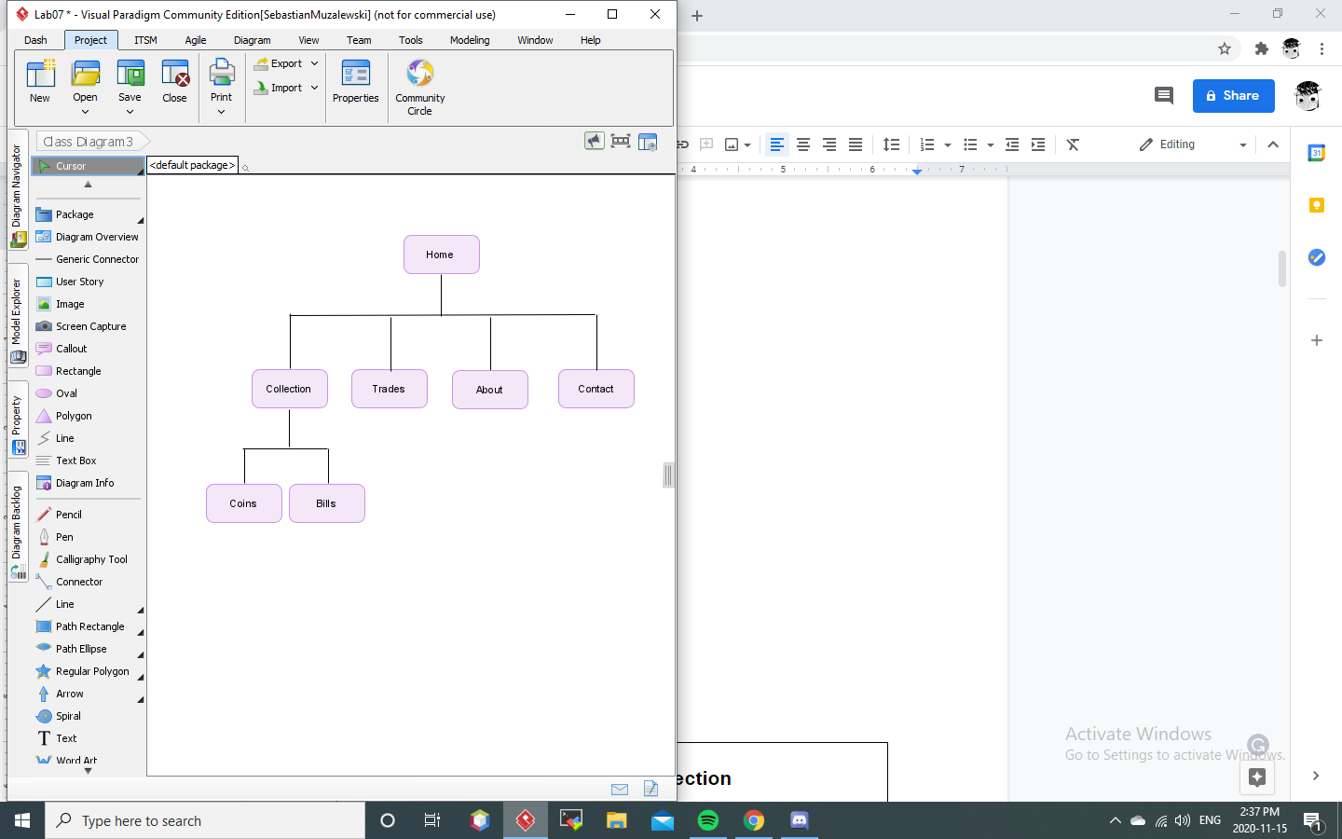

**Task 3: Web Project Layout Design:**

**Home Page:**

|  |
| --- |
| **Cash and Coin Collection** |
| **Home | Collection | Trades | About | Contact** |
| **Welcome!**  Welcome to my Cash and Coin Collection website. My name is Sebastian Muzalewski and I collect various coins and bills. To learn more about me and my favorite hobby, collecting visit the About page. If you are interested in seeing what is in stock this month, visit the Collection page.  Audio recording:  <source>  **Trade :**  If you are interested in trading a specific coin or banknote with me, you can visit the Trade page for a step by step instruction on how to trade with me. Then you may visit the Contact page to learn more about the specifics.  Audio recording:  <source> |
| Copyright © 2020 Cash and Coin Collection |

**Note:** Audio Recordings are produced by the student.

**Collection Page:**

|  |
| --- |
| **Cash and Coin Collection** |
| **Home | Collection | Trades | About | Contact** |
| **Collection:**  This is the Collection Page, where two categories will be displayed; Coins and Bills. For both links, there will be four displayed images and descriptions of each type of banknote and coin to be offered. **Please be mindful of the alert message at the bottom of the page**, it will display how long the coins and banknotes will be offered for the current month.  **Coins:**  Click here to view Coins available. Be mindful that only a handful of coins can be seen since they change every month for viewing  **Bills:**  Click here to view Bills available. Be mindful that only a handful of bills can be seen since they change every month for viewing  | Amount of time left | |
| Copyright © 2020 Cash and Coin Collection |

**Coins Page:**

|  |
| --- |
| **Cash and Coin Collection** |
| **Home | Collection | Trades | About | Contact** |
| **Coins:**  This is the coin section please enjoying viewing what is currently in my collection:  1.) Coin 1 on display:    ➤Details   * Name: The Peaceful Panda * Condition: Mint * Year released: 2018 * Features: Created with pure silver * Cost: $25.00CAD   2.) Coin 2 on display:    ➤Details   * Name: Confederation Canada * Condition: Near Mint * Year released: 1867 * Features: Created with Brass * Cost: $45.00   3.) Coin on display:    ➤Details   * Name: Maple Leaves * Condition: Mint * Year released: 2018 * Features: Created with pure silver * Cost: $15.00 |
| Copyright © 2020 Cash and Coin Collection |

**Bills Page:**

|  |
| --- |
| **Cash and Coin Collection** |
| **Home | Collection | Trades | About | Contact** |
| **Bills:**  This is the bill section please enjoying viewing what is currently in my collection:  1.) Bill 1 on display:    ➤Details   * Name: Ten Dollar Lawson-Bouey * Condition: Near Mint * Year released: 1971 * Number: EEW8070919 * Cost: $130.00   2.) Bill on display:    ➤Details   * Name: Twenty Dollar Queen Elizabeth II * Condition: Mint * Year released: 1979 * Number: ALT4931245 * Cost: $45.00   3.) Bill 3 on display:    ➤Details   * Name: Twenty Dollar Queen Elizabeth II * Condition: Mint * Year released: 2004 * Number: EE8621134 * Cost: $30.00 |
| Copyright © 2020 Cash and Coin Collection |

**Note:** All images were taken from my personal collection

**Trades Page:**

|  |
| --- |
| **Cash and Coin Collection** |
| **Home | Collection | Trades | About | Contact** |
| **Trades:**  For individuals that would like to trade personally with me for specific coins and banknotes must read the How to offer a trade section of the page. **Please read** the policy section underneath so that you know what to expect when requesting to trade with me.  **Policy:**  Before you offer a trade please read this **IMPORTANT** information:  • I am very serious about trading  • I do not accept fake or damaged items  • The coin or banknotes which you wish to pay for are the final prices (This mean no haggling)  • Please be mindful of the items which I have currently displayed in Collection, **I will not** trade previously sold items  **How to offer a trade:**  If you want to offer a trade you must reach out to me on the Contact page. The following steps are meant to act as a guideline for how the information should be sent:  1. Enter your name and age. Please not ages under 18 will not be accepted to trade.  2. Enter the address or location you wish to receive the package.  3. Enter an email and phone number that can be reached out to you. I recommend that you use Gmail or Hotmail however, any other form of other emails should be fine.  4. Enter the specific item you wish to trade for.  5. Check over all the information and then proceed to click the submit button to finish.  **What steps are next:**  If you have been successful with submitting all the required information you will receive an email with a list of instructions for the trade otherwise, you will receive a denial email listing the problem that has been encountered with the trade. **Please note** if you wrote an email without following the steps above it will not be ignored |
| Copyright © 2020 Cash and Coin Collection |

**About Page:**

|  |
| --- |
| **Cash and Coin Collection** |
| **Home | Collection | Trades | About | Contact** |
| |  |  | | --- | --- | | **Collecting experience:** | I started collecting about 5 years ago. My collection started off with only a few coins and bills. The goal was to keep everything in pristine condition in order to avoid items that were damaged or fake. Since then my collection has expanded to contain various coins and bills throughout history and events. | | **The Goal of this Site:** | My mission is to help individuals with trades so that they are able to complete their collection without the hassle of looking elsewhere. Over the last couple of months, I have received over 100 successful trades with the same individuals coming back for more. | | **Site management:** | I am the only individual who runs this website and I am proud of how far it has come. The site is meant to look visually appealing to users so they feel comfortable when they are requesting to trade or looking through my collection. Currently, I am not looking for individuals to help me out. | | **Trade Guarantee:** | The trades that are offered are based on real banknotes and coins. This guarantees that if you were to receive an offer, you will know that you get what you paid for. | | **How to find success:** | I believe that collecting is a very fun hobby and it does not have to include coins or bills. It can be anything that your heart desires. Be confident and smart when collecting and you will come very far from where you have started. I am always glad to see other individuals’ collections grow as does mine. | |
| Copyright © 2020 Cash and Coin Collection |

**Contact Page:**

|  |
| --- |
| **Cash and Coin Collection** |
| **Home | Collection | Trades | About | Contact** |
| **Contact:**  If you are interested in contacting me personally for business relations, Please contact me from the currently available listing. Otherwise, skip to the bottom of the page where you are able to input your information for trading.  **List of available business currently:**  • For business inquires contact me at this email: CashandCoinBuisness[@gmail.com](http://localhost:8383/assignment01/Sebastian@Muzalewski.com.html)  • For business inquires contact through the phone: 647-111-1111  **Contact Information:**  **Please input the following information about yourself:**  Name:  | |  Age:  | |  Address:  | |  E-mail:  | |  Phone Number:  | |  Please Enter the item name:  | |  |Send now| |
| Copyright © 2020 Cash and Coin Collection |